**DAILY ONLINE ACTIVITIES SUMMARY**

|  |  |  |  |  |  |  |  |  |
| --- | --- | --- | --- | --- | --- | --- | --- | --- |
| **Date:** | **27-5-2020** | | | | | **Name:** | **Poojashree T** | |
| **Sem & Sec** | **8th sem B sec** | | | | | **USN:** | **4al16cs065** | |
| **Online Test Summary** | | | | | | | | |
| **Subject** | | **IOT** | | | | | | |
| **Max. Marks** | | **28** | | **Score** | | | **30** | |
| **Certification Course Summary** | | | | | | | | |
| **Course** | **R language tutorial** | | | | | | | |
| **Certificate Provider** | | | **Great learning academy** | | **Duration** | | | **3.0hr** |
| **Coding Challenges** | | | | | | | | |
| **Problem Statement:** **1**. **to read the number and compute the series.**  **2. to count the number in th series.**  **3. to check whether number is palindrome or not.**  **4. to find the number between 0 and 50 which are not divisible by 2 and 3.**  **5.micro and array update**  Top of Form | | | | | | | | |
| **Status:completed** | | | | | | | | |
| **Uploaded the report in Github** | | | | | **yes** | | | |
| **If yes Repository name** | | | | | **Poojashree T** | | | |
| **Uploaded the report in slack** | | | | | **yes** | | | |

**Online test**

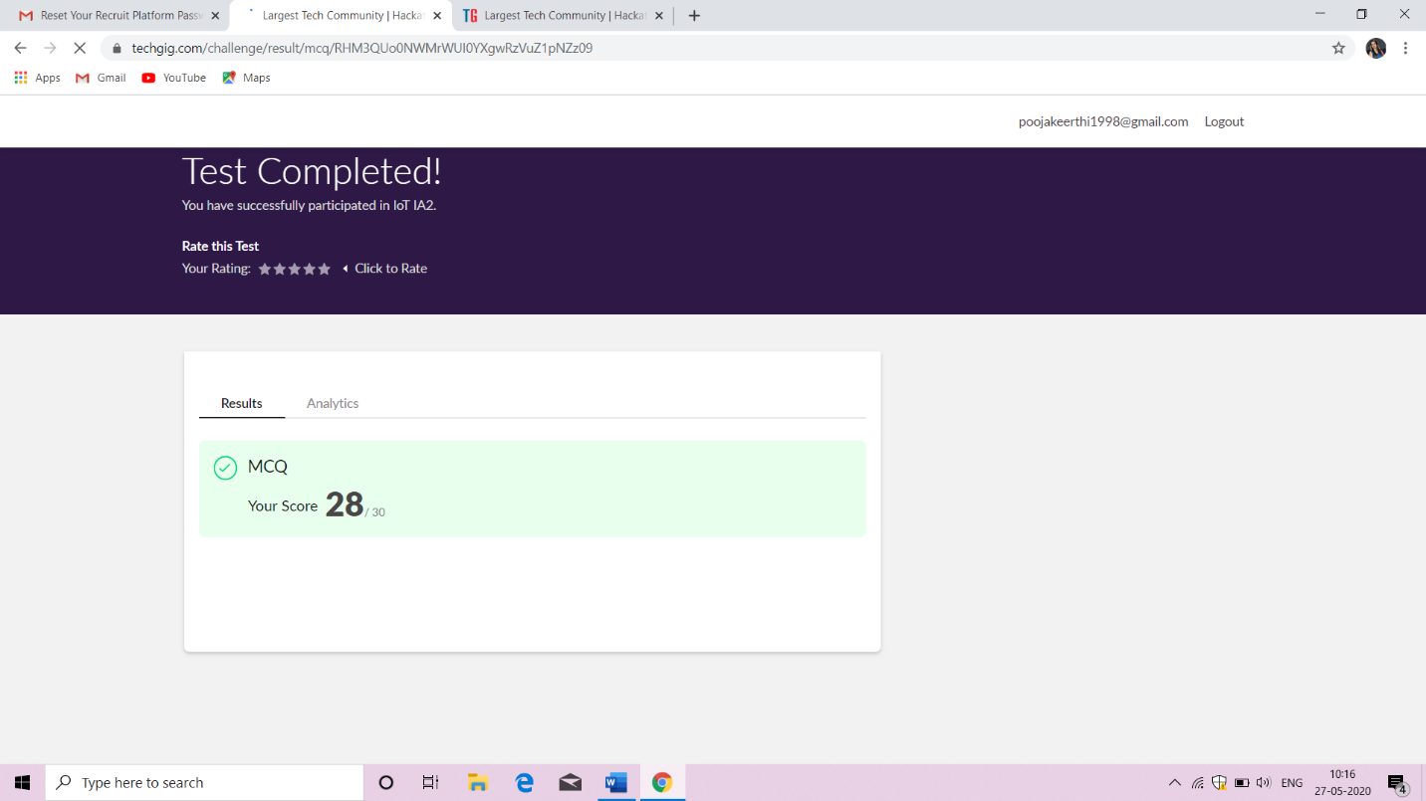

**Certification course**

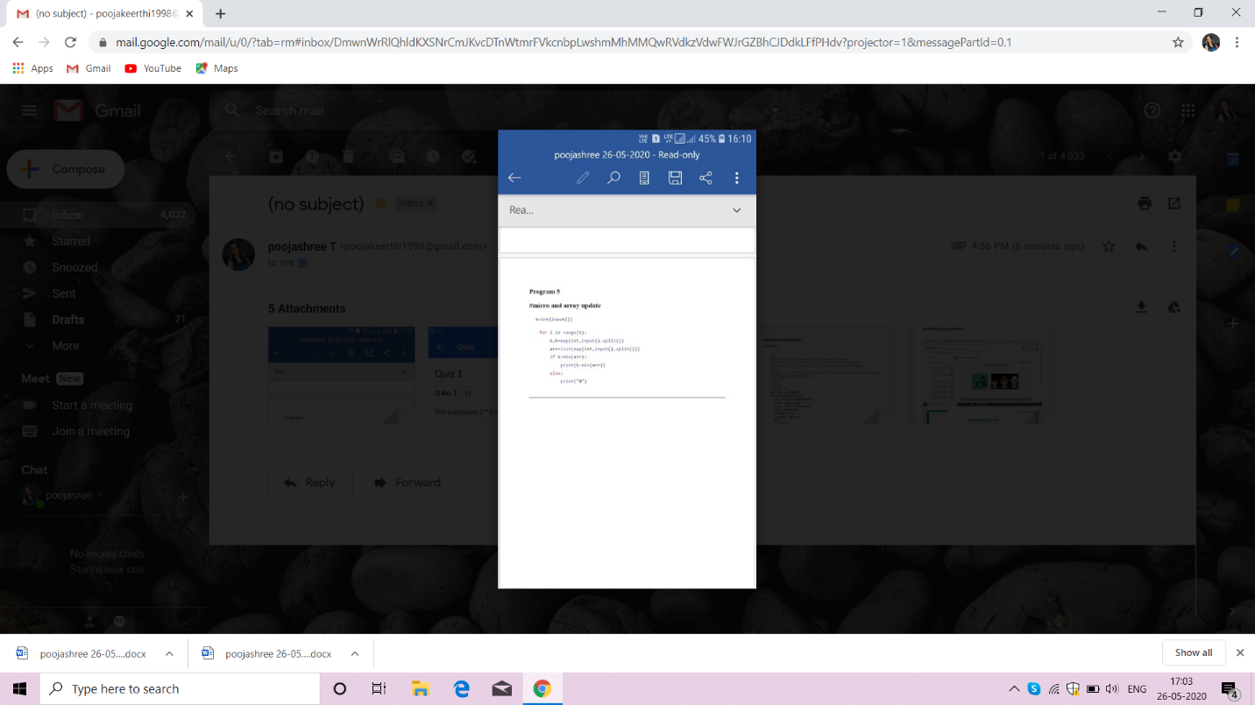

Coding

**Program 1**

**#to read the number and compute the series**Top of Form

|  |
| --- |
|  |
|  | n=int(input("Enter a number: ")) |
|  | a=[] |
|  | for i in range(1,n+1): |
|  | print(i,sep=" ",end=" ") |
|  | if(i<n): |
|  | print("+",sep=" ",end=" ") |
|  | a.append(i) |
|  | print("=",sum(a)) |
|  |  |
|  | print() |

Bottom of Form

Top of Form

Bottom of Form